Minutes of TNP Meeting held March 30, 2022
- Welcome & agenda for today’s meeting
  - In Attendance: Jennifer Rolinson (NPS), Margaret Watt (Positive Directions & parent), Diamond Sead (HSC & parent), Denique Weidema-Lewis (Norwalk ACTS), JoAnn Malinowski (NPS), Diana Revolus (advocate, council member, business owner, parent), Cadence Pethany (TCC), Dave Walenczyk (Youth Services), Ginger Katz (Courage to Speak), Amy Jefferies (FCA), Jahliah Green, Nicole Hampton (person in recovery, parent), Gail Melanson (MFCGC), Kaitlin Comet (The Hub), Marilyn Moreau (FCA), Eve St Surin (CAAWC), Paige Sinchak (MFCGC), Victoria Pereira (MFCGC), Alyssa Martinez (FCA), Jim Martinez (NPA), Anamilena Moreno (Norwalk ACTS), Doreen Maher Anderson (parent & community advocate), Aaron Katz (EMS), Mireiya Mayorga (FCA), Katarina Masilamani (FCA)
  - Welcome to new participants:
    - Aaron Katz, Norwalk Hospital EMS
    - Katarina Masilamani, Community Health Worker-FCA
    - Alyssa Martinez, Community Health Worker- FCA
    - Paige Sinchak, MFCGC- Norwalk High School
    - Doreen Maher Anderson, community advocate & parent
    - Lisa Gregory, peer engagement specialist, Community Care Team at Norwalk Hospital
    - Victoria Pereira- MFCGC- Brien McMahon
      - Both Paige and Victoria are continuing as full-time positions and will be working at the respective high schools continuously.
- Review agenda ; Announcements / updates
  - Positive Directions is hosting a new free Teen Support Group on anxiety as well as offering a Teacher Support Group which is starting in the coming weeks. All information is available on www.positivedirections.org/events
  - MFCGC is offering the Healing Arts Program to offer therapeutic art and music for ages 5-18 (drum circle, songwriting group, art therapy) For more information, call the MFCGC main number; more information will be forthcoming. MFCGC takes all insurance and scholarships are available.
  - Ase Kreationz is working with Dr. Bruno on the positive benefits of art to mental health. Get out there. More holistic understanding. Professionals that look like them. Dr. Bruno
  - As a reminder, the City of Norwalk Youth Services offers free care coordination to families. A Spanish-speaker Care Coordinator has been hired. Family Navigators are available to assist in English, Spanish, and Haitan Creole.
- Update on Coalition Activities
  - Alcohol - Teen Night Out idea, St Patrick’s
    - In previous years, For St. Patrick’s Day, able to connect restaurants to the TNP work. Would they advertise TNP, 21 Campaign. Liquor Safety Campaign. Great strong relationship with pubs.
    - Kids are complaining about a lack of things to do. The Norwalk YSB has been open to exploring this idea; working together to get the community and organizations to host safe, substance-free, and affordable programming for Norwalk teens that are geared toward their interests. If interested in being a part of this, please contact Diana (drevolus29@gmail.com) or Margaret (mwatt@positivedirections.org) .
      - Wellness Day on Friday at McMahon which will focus on Mental Health
      - Hosted a table today on Norwalk High
  - Vaping - vaping materials & activities in schools
    - 400 teens (150 Norwalk High/250 McMahon) participating at the monthly vaping table. Don’t know as much as they thought. Posters and other materials are being ordered at both of the middle and high schools and be visible within the bathrooms, SBHCs, and at the front door.
      - ACTION/COMMITMENT FOR TNP MEMBERS: If there is community interest to post posters, please let Diamond know (dsead@hscct.org) .
  - Marijuana - top 10 facts about MJ; public hearing on sales & billboards; Norwalk action required https://www.lamar.com/About/Support/ContactUs; federal action alert https://www.cadca.org/advocate-now?vvsrc=%2fCampaigns%2f93395%2fRespond
    - The facts generated discussion via the TNP social media pages. The internet is a turbulent. This issue is a politically sensitive topic. If you can be a voice of reason via social media,
    - Legislatively- Public Hearing of the Public Health Hearing, bill passed out of committee which would modify the marijuana bill. Would not make the prevention and health recommendations but would ban all forms of advertising marijuana and get rid of the ‘Hide Bazaar’ loophole; paid admission for giving away marijuana samples. Within current law, it limits billboard advertising (not within 500 ft of schools; doesn’t apply to preschools or colleges), no advertising unless you can prove (90%) is of majority age. Medical marijuana billboard on Westport Avenue and is less than 500 ft of Bright Beginnings and within walking distance of Norwalk High School.
      - ACTION/COMMITMENT FOR TNP MEMBERS: Prevention science demonstrates that substance advertising has an impact on underage use. Ask LAMAR to move the sign (Lamar Advertising | Contact Us); with the potential of follow-up with the Attorney General.
      - ACTION/ COMMITMENT FOR TNP MEMBERS: A Federal Action Alert has been provided on potential legislative action to lift the Schedule 1 ban on marijuana. Ask Congressman to vote against this due to lack of protections. For more information or editable script: Advocate Now | CADCA
  - MH month & National Prevention Week (May): Save the date for our awareness Walk + Check In fair on town green - May 7th in the morning, rain date May 14, 2022
    - Doreen is chair; fill out the provider survey if you haven’t already. Flyer is forthcoming. https://forms.gle/sspwnfX9oYQ8jvpC6
    - Some may have done regional mental health walk. Adding a resource fair with interactive tables. Much thanks to NCC for paying for the licensing to the Jordan Porco Foundation ‘Check in’ event. This is an opportunity to raise visibility of mental health and substance use resources for teens and families.
  - Teen clubs - Marijuana awareness tables this week in the schools - 115 students engaged at NHS
    - A lot of students didn’t know cannabis or THC; happening again tomorrow at McMahon.
  - Opioids - opioids/Narcan training for 45 school nurses and 15 security guards; CGS; last month trained Community Care Team; YouThinkYouKnowCT.org campaign
    - Diamond and Margaret can do NARCAN training; there is a possibility to schedule an QPR/opioid/NARCAN community training through this meeting in addition to getting more NARCAN to teachers and for 12th graders transitioning to college (trainings have historically been 18+ but there is a possibility of younger students to be trained with parent permission).
    - ACTION/COMMITMENT: There is a new regional campaign: YouThinkYouKnowCT.org which will include bus advertising, geofencing social media ads, if at SONO mall, an ad will cycle through. Take pictures of anything that you see of the campaign.

- Focus on Alcohol
  - Note: Police Dept was unable to attend to share their data and what they are seeing, as planned.
  - Alcohol data - Norwalk youth, adults, awareness of risks: Based on the 2020 Youth Survey data…
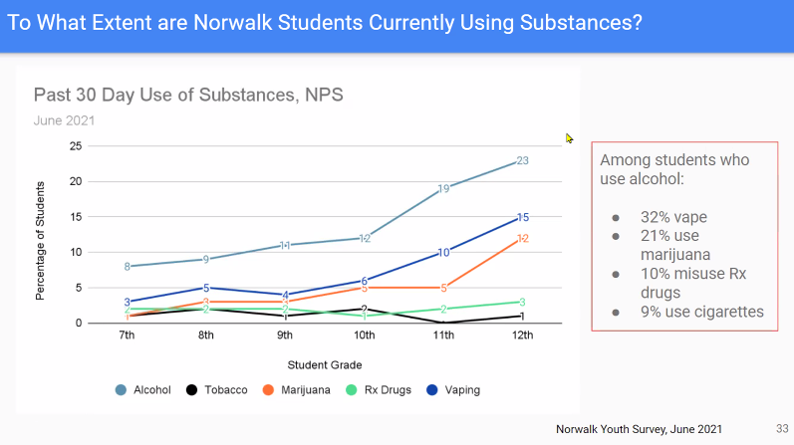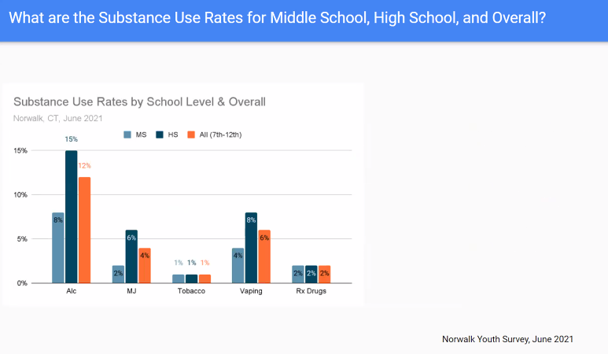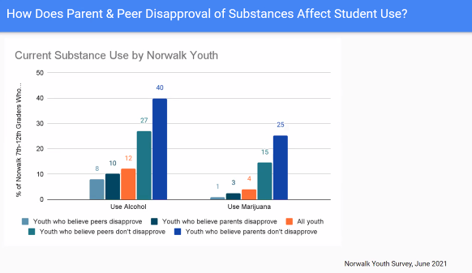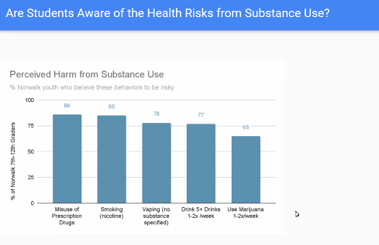
Next year is a survey year so planning should include an inclusive conversation to know what we need to know? Are there substances that we need that currently aren’t? Exposure to other drugs? There may be an opportunity to include focus groups and key informant interviews.
  - Report on parents / schools - Planning around prom / graduation
More information needed on prom/postprom/graduation plans at the high schools. This may be an opportunity for increased coordination/working across sectors (parents/ youth/ schools/ business) to provide safety messaging/ what awareness can we raise as TNP?
ACTION/COMMITMENT: Paige will make contact with those who are coordinating junior and senior prom at Norwalk High. Victoria will follow-up at McMahon.
  - Talk. They Hear You campaign
ACTION/COMMITMENT: Be on the lookout for the campaign.
  - Awareness: social host law; health risks; driving
HELD FOR TIME
  - Environmental strategies: signage, access, enforcement - bag checks, compliance checks
HELD FOR TIME

- Upcoming Dates - RSVP to Rebecca at roliveira@positivedirections.org for Zoom
  - TNP marijuana/vaping committee Thurs. Apr. 7th, 4-5pm
  - TNP alcohol committee Wed. Apr. 13th 4-5pm
  - NEXT COALITION MEETING: April 27, 2022 from 2-3:30pm
  - MAY MEETING WILL BE LIVE AND SERVE AS ANNUAL MEETING!
  - No meeting in June; working meeting in July; no meeting in August

