Agenda for Kickoff Meeting, September 30, 2020
Attendees: Margaret Watt (Positive Directions), Diamond Sead (HSC), Denique Weidema-Lewis (Norwalk Acts), Tory Sullivan (BMHS), Ginger Katz (Courage to Speak), Nina Chanana (TNP evaluator), Laila McGeorge (Norwalk Partnership intern), Emilia Anello (VOCA @ Child Guidance Center), Sgt David Orr (NPD), Giovanna Mozzo (The Hub), Peter King (Alateen Sponsor), Shamariah Grant (Norwalk Hospital Intern), Brian Griffin (Greater Norwalk Chamber of Commerce) Christine miller, Lamond Daniels (Chief of Community Services Norwalk), Edward Milton (KIC NW), Eve St. Surin (CAAWC Norwalk), Jeffrey Greenblatt (CT counseling centers), Jen Hrbek (Positive Directions), Lisa Cooper (open door shelter), Maria Escalera (HS Director Norwalk), Nicole Hampton (Norwalk Hospital), Pat Tinto (Communications Consultant) , Wendy Mendes (NCC), Kelsey Ciarleglio (High Focus Centers), Dave Walenczyk (Norwalk Youth Services), Eliza MacNamara (Smart Recovery) , Jessica Minieri (ICAN Norwalk Hospital), Anamilena Moreno (Norwalk Acts)

Welcome to The Norwalk Partnership!  - Vision & mission  - How the new group came to be  - Introduction of current leadership & new Prevention Intern | Diamond Sead, Human Services Council & School-Based Health Centers, Brookside parent
Introductions  - Your name, the group you represent  - Please share what you see as the main substance use issue in your personal or work life here in Norwalk  - SEE NOTES NEXT PAGE | Diamond
Why a substance use coalition? (Slideshow)  - How does substance use relate to our community concerns?  - What is a coalition approach?  - SEE SLIDESHOW | Margaret Watt, Positive Directions, NHS and P-TECH parent
What do we know about substance use in Norwalk?  - SEE NOTES NEXT PAGES  - Poll (completed the poll only)  Question 1: 67% alcohol 25% nictione 4% marijuana 4%prescription  Question 2: 33% around 8, 17% 9-10, 8% middle, 8% high school, 33% no kids  Question 3: 0-10, 46% - 20, 33% - 40, 21% - 60  - Risky behaviors (2018 youth survey)  - Positive assets and social-emotional | Nina Chanana, evaluator  Denique Weidema-Lewis, Norwalk ACTS
Next steps  - Involvement beyond the monthly meetings  - Social media (@NorwalkPartnership)  - Help organize a parent or youth focus group?  - Next meeting: Wednesday, October 28th, 2-3:30pm | Margaret & Diamond

- Your name, the group you represent, what you see as the main substance use issue in your personal or work life here in Norwalk
- Denique Weidema-Lewis (Norwalk Acts), Alcohol use; prevalence of marijuana use and low perception of harm.
- Tory Sullivan (BMHS), Ginger Katz (Courage to Speak), low perception of harm and casual attitude around marijuana use, marijuana use rates.
- Laila McGeorge (Norwalk Partnership intern), marijuana use; vaping
- Sgt David Orr (NPD), Greatest issues in schools right now is marijuana use through vapes, odorless makes it is easy to hide, little to no perception of harm. Also concerned with youth ingesting narcotics and uptick in PCP use.
- Giovanna Mozzo (The Hub), “Use of marijuana as a drug is not frowned upon anymore”; alcohol is still most prevalent substance use; vaping is focus with LPCs and need to include vaping THC.
- Peter King (Alateen Sponsor), Katz? Most teens are struggling with their parents use of alcohol; their own use seems to be primarily with vaping and marijuana.
- Shamariah Grant (Norwalk Hospital Intern), alcohol use
- Edward Milton (KIC NW), Marijuana – there is a big need to educate around marijuana and harmful effects, “Don’t’ even see marijuana as a drug”; also concerned about vaping as use is so discreet in schools.
- Eve St. Surin (CAAWC Norwalk), Concerned about vaping, marijuana use and pills. Often parents are not aware of what their kids are taking.
- Jeffrey Greenblatt (CT counseling centers), finding a lot of fentanyl in heroin as most patients they treat do not know. Since the pandemic they are seeing a lot of alcohol use in panel screens of patients.
- Jen Hrbek (Positive Directions), Alcohol, vaping nicotine, and marijuana use are all a concern.
Also young people experimenting with PCP.
- Lisa Cooper (open door shelter), Alcohol use issue with families in shelter; also seeing an uptick in PCP use.
- Maria Escalera (HS Director Norwalk), Marijuana, alcohol and vaping. Also access to RX drugs.
- Nicole Hampton (Norwalk Hospital), seeing an uptick in PCP.
- Wendy Mendes (NCC), Have had some discipline cases around marijuana and vaping use at school. Some students are in recovery around opioid addictions.
- Kelsey Ciarleglio (High Focus Centers), Vaping and marijuana use.
- Dave Walenczyk (Norwalk Youth Services), cannabus and alcohol.
- Eliza MacNamara (Smart Recovery), In SMART groups biggest topic is marijuana use especially vaping. Good number of youth get the marijuana from their parents (both they take it from them and/or they smoke it with them.) Strange dynamic with parents going from punitive to acceptance.
- Jessica Minieri (ICAN Norwalk Hospital), Casual attitude around and prevalence of vaping among youth.

- How does substance use relate to our community concerns? Additional community concerns:
- Food insecurity
- Housing evictions
- Mental health

- What is happening in our community now?
- Eliza -in a youth group – stress of COVID, no jobs, brought up fear and trauma – now using alcohol to cope.
  - A lot of members who use marijuana heavily would like to stop but struggle with the peer pressure (not ‘you are a loser if you don’t smoke’) – as in, so many of their peers are using and using often. Peer support is critical.
- Lisa Cooper – at the shelter, more young adults coming in. using alcohol as a coping tool. For women coming to the shelter drinking is a huge issue.
- Eve St. Surin – seeing within families – kids using marijuana during lockdown, causing issues and kids using to cope. Situations where kids would runaway from home and stay away for days. Lack of open (non-virtual) services was an issue.
- What percentage of your work is effected by substance use:
  - The Narcotics/Vice department takes about 5% of total calls. (in comparison domestic violence call is 25%). Call for narcotics is much lower than when compared to 20 years ago. Street level sales are way down. Now all transactions are done via cell phone and this makes substances more accessible to youth. There are an abundance of app’s that you can use to source narcotics (eg. Kik, Snapchat) – there are local source groups on Kik that will meet up in parking lots. (Heroin is still sometimes sold on street but usually early in the morning.)
  - Also find many illegal THC cartridges and no idea what is in them.
- Polls
  - Alcohol is most common first substance used among members.

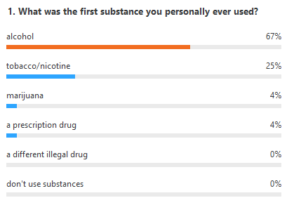
  - Members with kids starting talking to them at a young age.

40% I correct 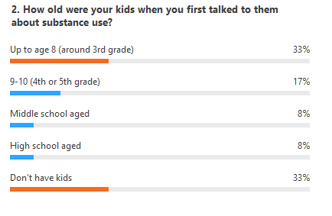answer
- 