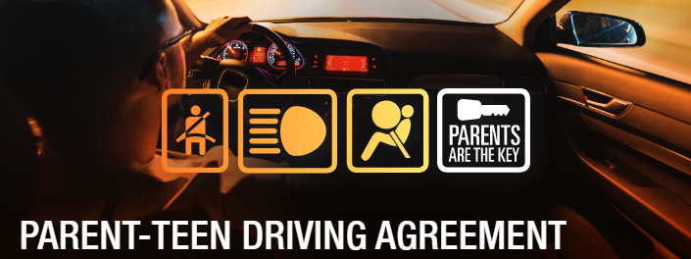

I, _________________________________________ (student), will drive carefully and cautiously and will be courteous to other drivers, bicyclists, and pedestrians at all times.
I, _________________________________________ (parent/guardian), will drive carefully and cautiously and will be courteous to other drivers, bicyclists, and pedestrians at all times.
I, _________________________________________ (parent/guardian), will drive carefully and cautiously and will be courteous to other drivers, bicyclists, and pedestrians at all times.
I, _________________________________________ (parent/guardian), will drive carefully and cautiously and will be courteous to other drivers, bicyclists, and pedestrians at all times.
PROMISE.
I promise that I will obey all the rules of the road.
⬜ ⬜⬜⬜Always wear a seatbelt and make all my passengers buckle up
⬜ ⬜⬜⬜Obey all traffic lights, stop signs, other street signs, and road markings
⬜ ⬜⬜⬜Stay within the speed limit and drive safely
⬜ ⬜⬜⬜Never use the car to race or to try to impress others
⬜ ⬜⬜⬜Never give rides to hitchhikers
I promise that I will make sure I can stay focused on driving.
⬜ ⬜⬜⬜Never text while driving (writing, reading, or sending messages)
⬜ ⬜⬜⬜Never talk on the cell phone — including hands free devices or speakerphone — while driving
⬜ ⬜⬜⬜Drive with both hands on the wheel
⬜ ⬜⬜⬜Never eat or drink while driving
⬜ ⬜⬜⬜Drive only when I am alert and in emotional control
⬜ ⬜⬜⬜Call my parents for a ride home if I am impaired in any way that interferes with my ability to drive safely,
or if my driver is impaired in any way
⬜ ⬜⬜⬜Never use headphones or earbuds to listen to music while I drive
I promise that I will respect laws about drugs and alcohol.
⬜ ⬜⬜⬜Drive only when I am alcohol and drug free
⬜ ⬜⬜⬜Never allow any alcohol or illegal drugs in the car
⬜ ⬜⬜⬜Be a passenger only with drivers who are alcohol and drug free
I promise that I will be a responsible driver.
⬜ ⬜⬜⬜Drive only when I have permission to use the car & will not let anyone else drive the car unless I have permission
⬜ ⬜⬜⬜Drive someone else’s car only if I have parental permission
⬜ ⬜⬜⬜Pay for all traffic citations or parking tickets
Complete my family responsibilities and maintain good grades at school as listed here:_______________________
____________________________________________________________________________________________
Contribute to the costs of gasoline, maintenance, and insurance as listed here: ____________________________
STUDENT RESTRICTIONS:  I agree to the following restrictions but understand that these restrictions will be modified by my parents as I get more driving experience and demonstrate that I am a responsible driver.  ⬜ For the next _____ months, I will not drive after  ________ pm.  ⬜ For the next _____ months, I will not transport  more than _______ teen passengers (unless I am  supervised by a responsible adult).  ⬜ For the next _____ months, I will not adjust the stereo, electronic devices, or air conditioning/heater while the car is moving.  ⬜ For the next _____ months, I will not drive in bad weather.  ⬜ I understand that I am not permitted to drive to off limit  locations or on roads and highways as listed here:  _________________________________________  _________________________________________  ⬜ Additional restrictions: ____________________  _________________________________________  _________________________________________ | PENALTIES FOR  AGREEMENT VIOLATIONS:  ⬜ Drove while texting (composed, read, or sent  message or email with phone).  NO DRIVING FOR ______ MONTHS  ⬜ Drove while talking on the cell phone (including  handsfree or speakerphone).  NO DRIVING FOR ______ MONTHS  ⬜ Drove after drinking alcohol or using drugs.  NO DRIVING FOR ______ MONTHS  ⬜ Got ticket for speeding or moving violation.  NO DRIVING FOR ______ MONTHS  ⬜ Drove after night driving curfew.  NO DRIVING FOR ______ WEEKS/MONTHS  ⬜ Drove too many passengers.  NO DRIVING FOR ______ WEEKS/MONTHS  ⬜ Broke promise about seat belts (self and others).  NO DRIVING FOR ______ WEEKS/MONTHS  ⬜ Drove on a road or to an area that is off limits.  NO DRIVING FOR ______ WEEKS/MONTHS

I agree to follow all the rules and restrictions in this agreement. I understand that my parents will impose penalties, including removal of my driving privileges, if I violate the agreement. I also understand that my parents will allow me greater driving privileges as I become more experienced and as I demonstrate that I am always a safe and responsible driver. I also agree to hold my parents/guardians accountable for safe driving.

I PLEDGE>>> SIGNATURES

Driver: _______________________________________ Date: ________________

Parent promise: I also agree to drive safely and to be an excellent role model.

Parent (or guardian): ____________________________ Date: ________________

Parent (or guardian): ____________________________ Date: ________________
WWW.CDC.GOV/PARENTSARETHEKEY

