Marijuana Committee Meeting Notes 8/4/21

Present: Laila McGeorge & Margaret Watt (Positive Directions), Diamond Sead (Human Services Council), Pete King (Alateen), Tory Sullivan (NPS), Diana Révolus(Common Council), Ginger & Larry Katz (Courage to Speak Foundation), Nina Chanana (project evaluator), Kelsey Ciarleglio (High Focus Centers), Denise Rollinson (), Dora De Andrade ()

DATA

Reviewed data collected during the past year related to marijuana:

From our Norwalk Youth Survey, June 2021:

1. CURRENT USE:

- 15% of high schoolers were using marijuana in the 30 days prior to the survey - cannot be compared to 2018 data because that was only 9th and 11th graders
- Marijuana use is significantly higher among the following groups:
  - Black youth
  - IEP
  - Food and Financial Insecurity
  - GLB+, prefer to self-describe
  - Those reporting sad/hopeless, considered suicide, attempted suicide

2. PERCEPTION OF HARM:

- Youth think it’s the least harmful substance of those they were asked about
- 42% of high school students did not think using marijuana a couple of times a week is not risky

3. PERCEPTION OF PEER & PARENT DISAPPROVAL:

- Perception of peer disapproval is lowest around marijuana use when compared to all other core substances.
  - 92% of Norwalk 7th graders think their peers disapprove
  - 48% of Norwalk 12th graders (Less than half)
- Norwalk teens who feel their peers have little to no disapproval of marijuana use are 3.5 times more likely to use marijuana compared to their peers who believe their peers do disapprove of use.
- Norwalk teens report lower parental disapproval of marijuana compared with other substances.
  - 91% of youth thought their parents disapproved.
  - 77% of 7th graders think their parents disapprove; by 12th grade it drops to 52%.
- Norwalk teens who feel their parents disapprove of marijuana are 4 times less likely to use it compared to their peers.

4. VAPING OF THC (MARIJUANA):

Among Norwalk youth who reported vaping – 43% used liquid/wax THC in the vapes (close to the same rate that reported use of liquid nicotine at 49%).

From our Community Survey, Dec 2020-March 2021:
- 16% of Norwalk residents believe using marijuana is a normal part of growing up.
- 30% of Norwalk residents believe that, in Norwalk marijuana is commonly used at home.

HS Focus Groups, October 2020 (22 juniors and seniors from Brien McMahon High School)
1. Majority said use has increased
- One male was not sure if increase was due to increased stress or being inside
- Another male thought increase was because of free time among peers.
2. Ease of Access
- Majority of youth felt it was Easy to get access to marijuana
- “overly easy”
- One female stated that she could “get it from 5 different people right now if I wanted to get it.”
3. Where is access from?
- Social media – Snapchat, Plugs, School, Friends, Parents – one female said she know about parents who give their child permission to use marijuana

5. QUALITATIVE DATA FROM COALITION MEETINGS

9.30.20
At the TNP meeting group was asked "What is the main substance use issue you see in your personal or work life here in Norwalk?" Marijuana was most often mentioned of the 29 attendees (included 11 of the 12 sectors (missing Media), with several representatives each from the treatment, parent, shelter, colleges, and voices of people in recovery.
- 14 mentions of marijuana (4 specifying vaping of marijuana), representing 9 different sectors.
- 9 mentions of alcohol, representing 6 sectors.
  - Only 1 person cited alcohol alone; most mentions of alcohol were in conjunction with marijuana.
  - The only times alcohol was mentioned without mentioning marijuana, it was the hospital, shelter, and a tx provider who mentioned fentanyl & PCP instead of pot, so I think this represents a difference in adult-serving vs youth-serving sectors.
- 7 mentions of vaping (6 not specifying the substance and 1 specifying nicotine), representing 5 sectors.
5.26.21
Report from Sgt. Orr:
2019: 52 citizen complaints to narcotic division; 117 possession charges
2020: 46 citizen complaints; 50 possession charges
2021: 62 citizen complains; 21 possession charges

Why less enforcement? General public does not look favorable to enforcement activities at this time. Diana: linked to Black male incarceration

“Common occurrence to smell marijuana in the field” “more so than ever”

Driving under the influence of marijuana: harder to detect; very few arrests. Usually picked up because of an accident or other traffic violation. At that time they can run a screen for marijuana.

Sgt. Barr: “kids using vapes all the time”. Officers go into shops and will do compliance checks. In Feb 2021 3 out of 4 failed checks.
6.7.21
Review local ordinances around signage, marketing, dispensary displays, etc. (share images of Westport dispensary versus other)
New hookah shop and a vape shop in SONO near the movie theater. The hookah shop has a big Delta 8 THC banner in front.

7.1.21
Email from community member:
“Your timing on is rather good, we were just talking about this about two hours ago. This summer I am working in Rowayton as one of the two district safety officers, one of our biggest worries is the continued trespassing of young adults at Bailey Beach and other district properties. It is easy to see that they have easy access to alcohol as empty bottles and cans are everywhere. There is also a wooded area behind a school parking lot where we see a lot of pot smoking and vaping. We believe all this is going to get a lot worse after marijuana is legal. The police turn a blind eye to most of the underage drinking and other problems in Rowayton, likely because of the affluence and privilege and the high priced lawyers that will make it all go away.”
Rowayton ES was also having big problems with substance use (lots of alcohol bottles) - older athletes at the school fields - but administration wouldn’t let the coaches have access to the info on who they were - so not possible to create consequences
PLANNING
1. LOGIC MODEL
Reviewed the prevention planning process.
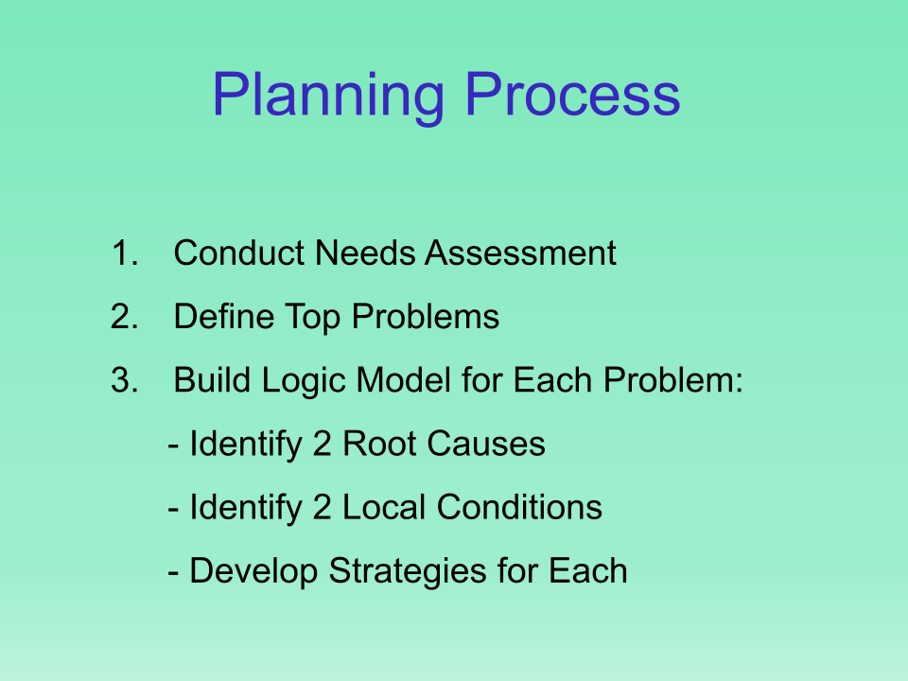
SPF planning & development of logic model & strategic plan the CADCA / DFC way:
- Use the assessment data to pick 2 priority substances.
- For each, create a problem statement in the most basic possible terms: Middle schoolers are drinking. Adults are driving drunk. Teens are binge drinking. High schoolers are using marijuana.
- Build a logic model

Reviewed the types of root causes underlying MJ use in Norwalk youth. Proposed parental favorable attitudes and community norms as the 2 major causes to address. Discussion included:
- Pete was concerned that the focus was not on teens, however teens will be empowered to help us implement and change norms and attitudes.
- Ginger and Larry Katz agreed with the root causes, adding that towns and cities are taking it upon themselves to say they don’t want it in their communities. Planning and zoning commission should get involved for mj shops and locations
- Diana stressed the importance of empowering teens and acknowledging parents and their experiences in parent education
- Denise noted that many teens she works with do not see the connection between marijuana use and mental health conditions. Her clients self-medicate with marijuana. Also noted that adolescents were using marijuana to deal with boredom, depression, and stress during the pandemic.
- 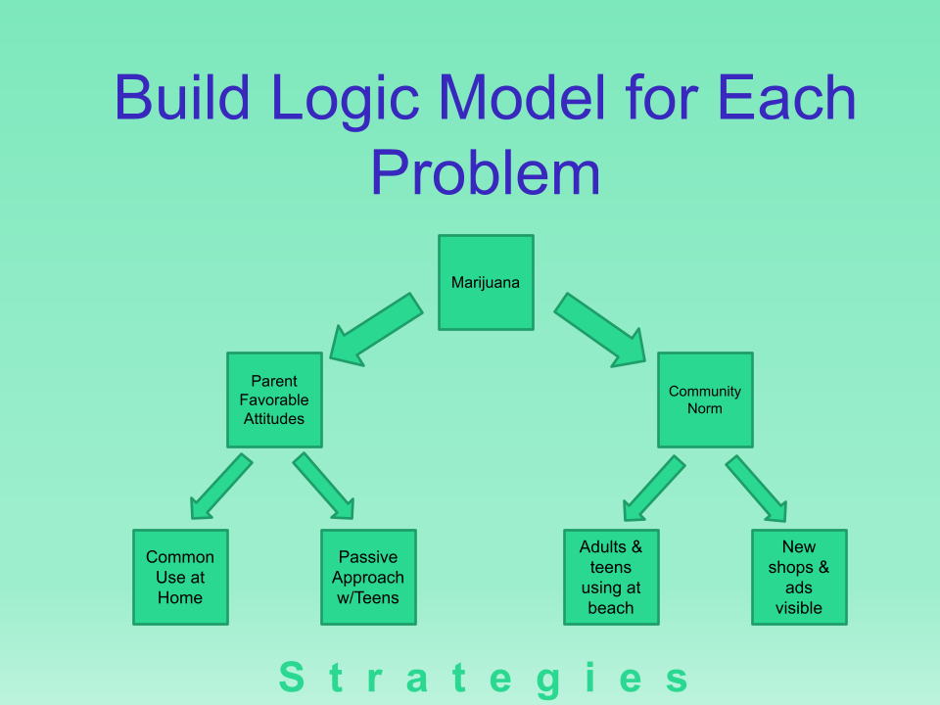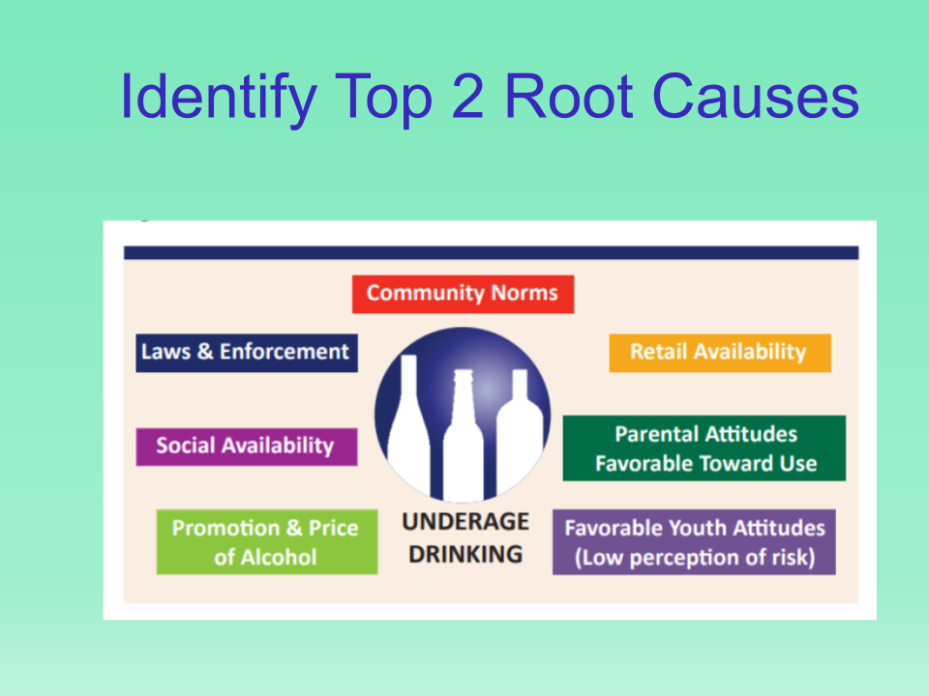
- Identified that we will address youth perception of harm by working with them through a club and in schools and by working with health teachers on curriculum.

2. NOTES ON STRATEGIES
Discussed types of strategies and messages during the conversation. Specifics to be worked on in subsequent meetings, including who delivers what content. Coalition members should plan to be involved.

EDUCATION FOR PARENTS:
- Differentiate messages for older vs younger parents
- Acknowledge parents’ experiences
- Haitian and Hispanic groups to develop their own

EDUCATION / SUPPORT FOR YOUTH:
- Youth clubs in both schools, coordinated by Laila
- Ed mentioned that there was a smoking lounge when he was in high school, now that’s unheard of. Changing community norms and perceptions can happen.
- Vaping campaigns have made a difference in perceptions of harm, usage
- CT DPH reported a 300% increase in hospitalization due to psychosis associated with marijuana between 2016-2019
  - Diana asks for more detail about whether these are first-time users & how long the illnesses last - Margaret will ask Mike Makowski from DPH
  - Kelsey: Has seen psychosis skyrocketing in teens.
    - Psychosis is a DSM-5 diagnosis; paranoia is one symptom
- Today’s product has been genetically engineered to be much stronger than in the past
- Connecting MJ consequences to sports / other participation (since basically no consequences in the new law)
- Edibles: kid from New Canaan had to be hospitalized
  - don’t have any survey data on edibles - but anecdotally it’s trending
  - people don’t realize how long it takes for edibles to take effect - so easy to overdose
- Tory said students more attracted to vaping b/c doesn’t smell - don’t know dangers of driving - need to educate
  - Health teachers educate about ingestion vs inhalation and the effects - more interesting for teens to know, helps understanding the difference between edibles etc. - health classes do cover this

COMMENTS:
- Dora - work with Hispanic pop
- Pete: work with teens - even as a 3rd wing of the logic model
- MW - shared TNP-NPS plans, teen group
- Ginger: parents are #1 influence
- Next meeting with be 9/9/2021 time TBD

