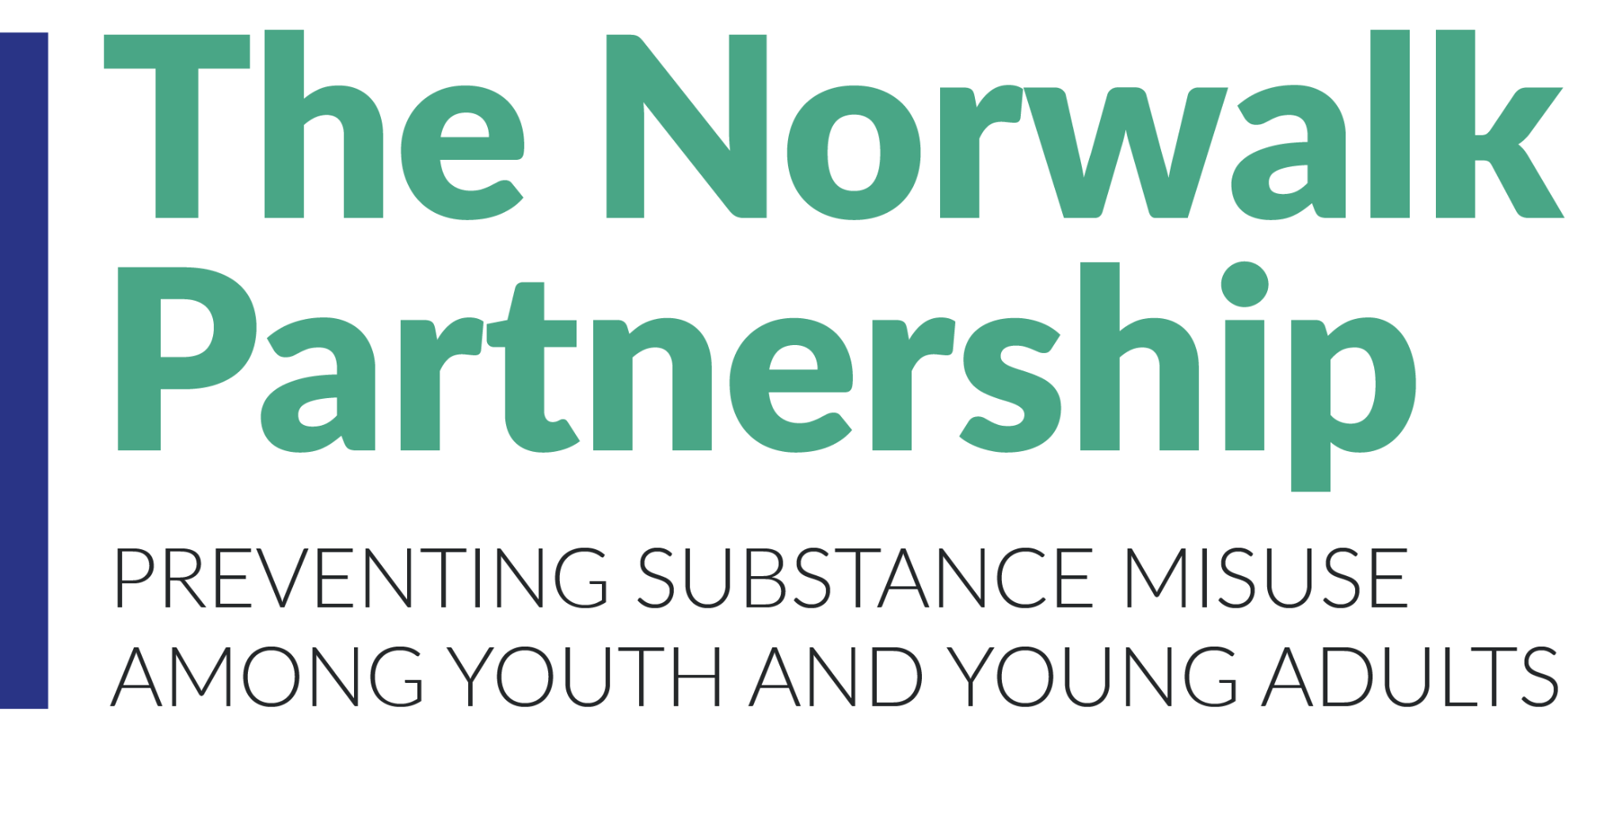
Minutes of 7/14/21 Discussion about Marijuana
Present: Laila McGeorge & Margaret Watt (Positive Directions), Diamond Sead & Anthony DiLauro (Human Services Council), Pete King (Alateen), Tory Sullivan (NPS), Diana Revolus (Common Council), Ginger Katz (Courage to Speak Foundation), Sabine Romsaint (Odyssey), Nina Chanana (project evaluator),
- Laila reviewed aspects of the new law (see slides below):
Links to:
- State cannabis website
- Summary of bill
- CT Mirror article 6/22
- CT Mirror op-ed by retired police officer 6/30
- List of recommendations by CT TTASC (statewide prevention group)
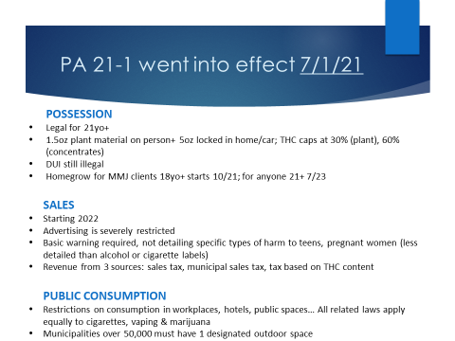
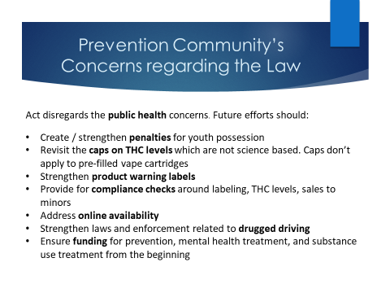
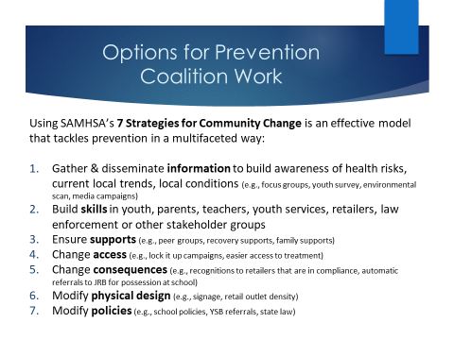
- Suggested that subcommittee meet over the summer to (a) revisit our marijuana logic model in light of the youth data we have just gotten back and the new law and (b) develop plans for the school year.
  - Options for our work can range from individual strategies like disseminating information and health education to environmental strategies like working at the community level to limit the density of retail stores selling vaping and marijuana related products, or to limit advertising.
  - Question was raised about whether it would even make sense to do something at the policy level vs working with youth specifically. The reason is that prevention research shows that environmental strategies are very effective. For example, CT passed the Tobacco 21 law almost 3 years ago and it had an effect on youth vaping. The 7 strategies for community change (see slide above) are all evidence-based methods of reducing risk to youth. However, they are strategies for community change which means they need community-level support, not just one stakeholder group Thus consensus on our priorities is important. We do not have capacity to do everything, so will need to be focused.

- Next Steps
  - Get more info from EMS
  - Check with Jim M as to whether we can do professional development for health& PE teachers in late August
  - Before next meeting, Nina will send the marijuana logic model and data
  - Next meeting August 4th at 3-4:30pm

